

Name: Sajjal Tariq
Roll No: 10011
Section: A
Submitted To: Sir Zohaib Khan

LAB NO. 01
Intro to Oracle DBMS SQL*PLUS environment

List the features of Oracle Database 11g
Objectives
Discuss the theoretical and physical aspects of a relational database
Describe Oracle server’s implementation of RDBMS and object relational database management system (ORDBMS)
What is SQL and basic SQL queries

Instructions
- This is individual Lab work/task.
- Complete this lab work within lab timing.
- Discussion with peers is not allowed.
- You can consult any book, notes & Internet.
- Copy paste from Internet will give you negative marks.
- Lab work is divided into small tasks, complete all tasks sequentially.
- Show solution of each lab task to your Lab Instructor.
- Paste your solution (i.e. code) in given space under each task.
- Also make a zip/rar archive of all lab tasks and upload this file on LMS before leaving lab.
- In-Lab Exercises/Tasks

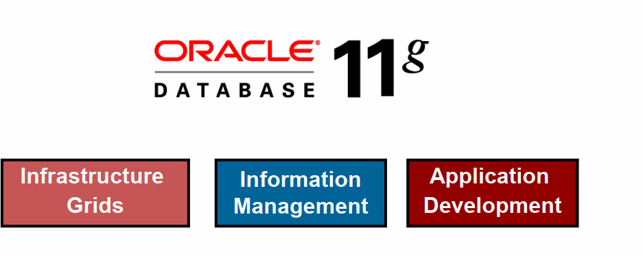
ORACLE DATABASE 11G: FOCUS AREAS
ORACLE DATABASE 11G

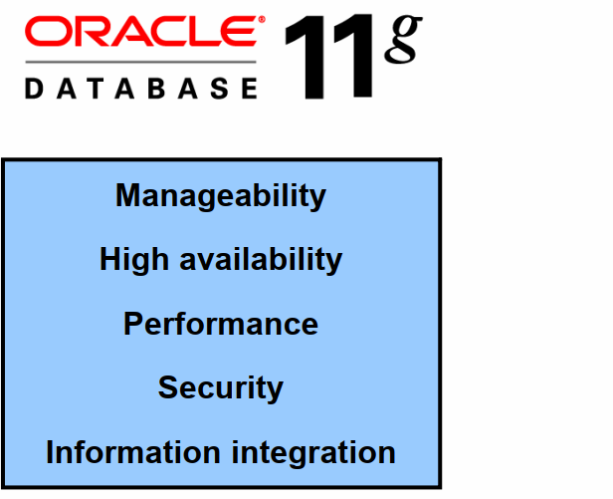

ORACLE FUSION MIDDLEWARE
Portfolio of leading, standards-based, and customer-proven software products that spans a range of tools and services from J2EE and developer tools, through integration services, business intelligence, collaboration, and content management
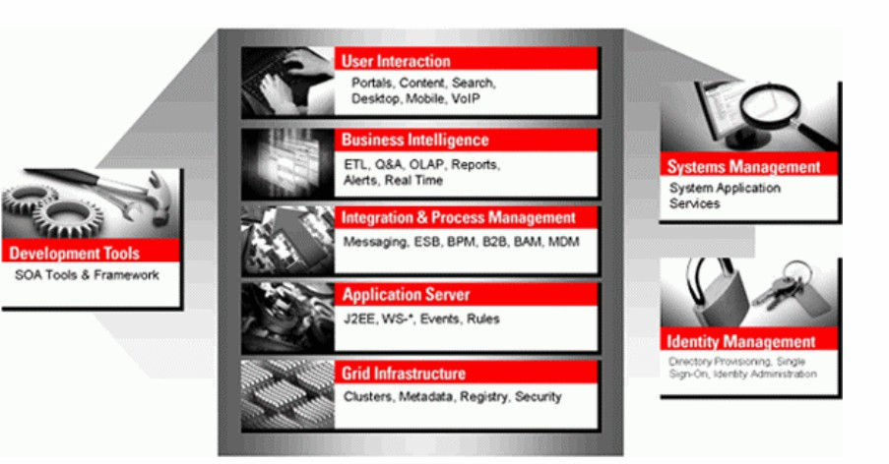

ORACLE ENTERPRISE MANAGER GRID CONTROL 10G
- Efficient Oracle Fusion Middleware management
- Simplifying application and infrastructure life cycle management
- Improved database administration and application management capabilities



ORACLE BI PUBLISHER
  - Provides a central architecture for authoring, managing, and delivering information in secure and multiple formats
  - Reduces complexity and time to develop, test, and deploy all kinds of reports
    - Financial Reports, Invoices, Sales or Purchase orders, XML, and EDI/EFT(eText documents)
  - Enables flexible customizations
    - For example, a Microsoft Word document report can be generated in multiple formats such as PDF, HTML, Excel, RTF, and so on.

What is SQL?
SQL stands for Structured Query Language and it is an ANSI standard computer language for accessing and manipulating database systems. It is used for managing data in relational database management system which stores data in the form of tables and relationship between data is also stored in the form of tables. SQL statements are used to retrieve and update data in a database.

Installing Oracle Database
Download oracle setup, after having the installation files which are in ZIP format, you need to extract them into a specific folder on your computer.

The following picture shows the structure of the folder of the Oracle installation files after extraction.
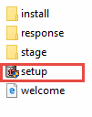

Now you need to double-click the setup.exe file to start the installation process. There will be 9 steps which mostly automatically execute.

Step 1. The installer asks you to provide your email address to get the latest security issues and updates. You can ignore it by clicking the Next button
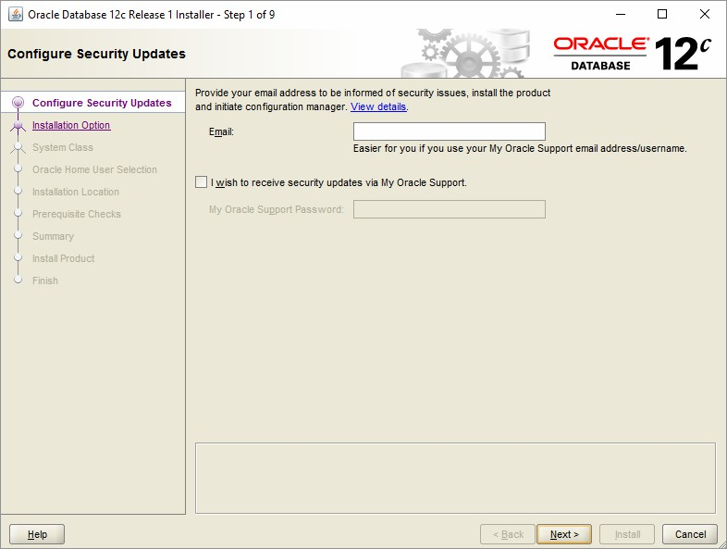
Because I didn’t provide the email address, the Oracle database installer confirm it, you just need to click the No button to continue.

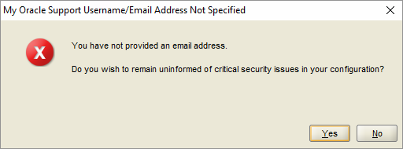

Immplement:
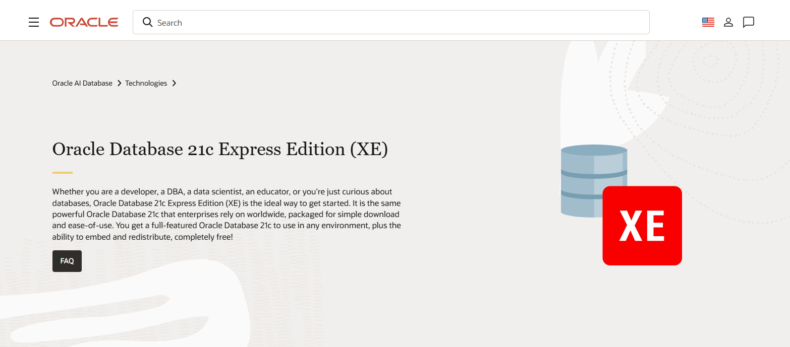

Step 2. In step 2, Oracle installer ask you to whether you want to create and configure a database, install database software only or just upgrade an existing database. Because you install the Oracle database at the first time, choose the option 1 and click the Next button.

Immplement:

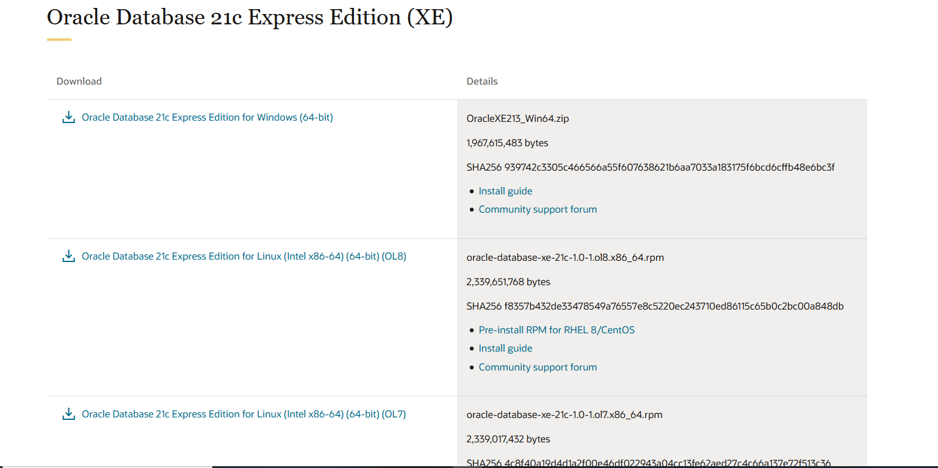

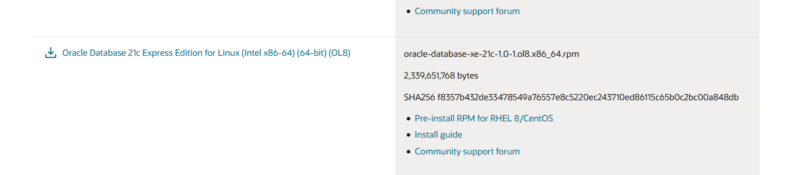

Step 3. The installer allows you to choose the system class. Because you install Oracle on your computer, not a server, therefore, you choose the first option: desktop class and click the Next button.

Immplement:

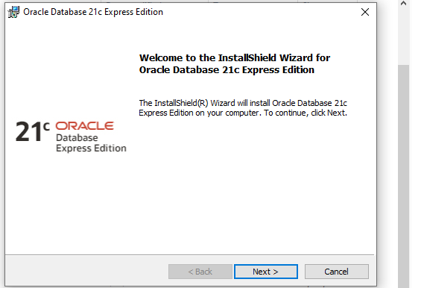

Step 4. This step allows you to specify the Windows user account to install and configure Oracle Home for enhanced security. Choose the third option: “Use Windows Built-in Account”.

Immplement:

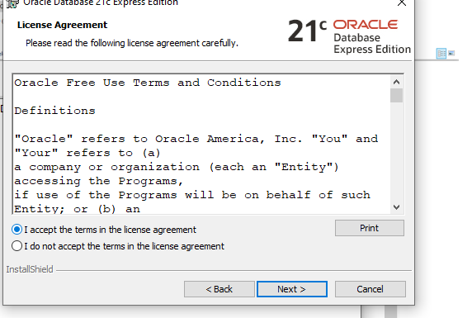
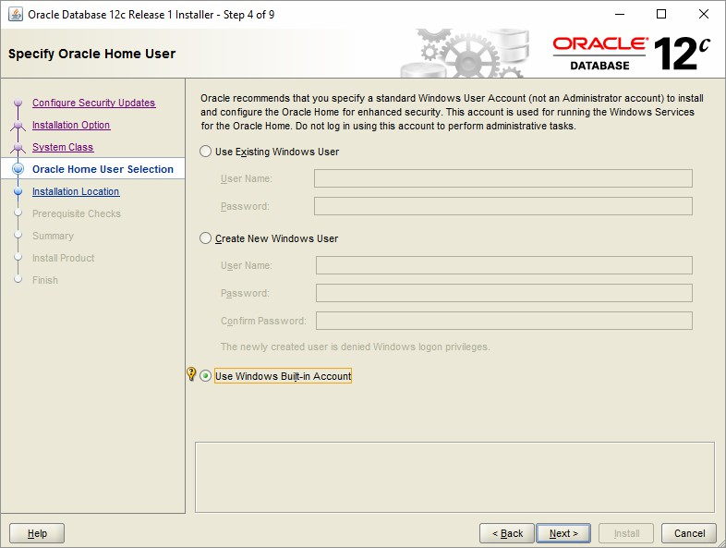
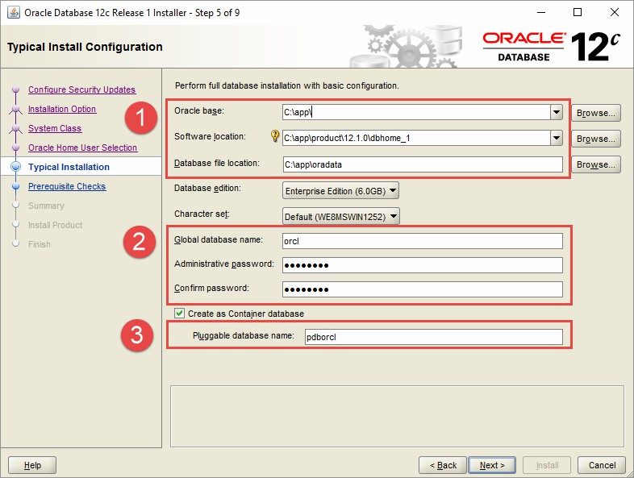
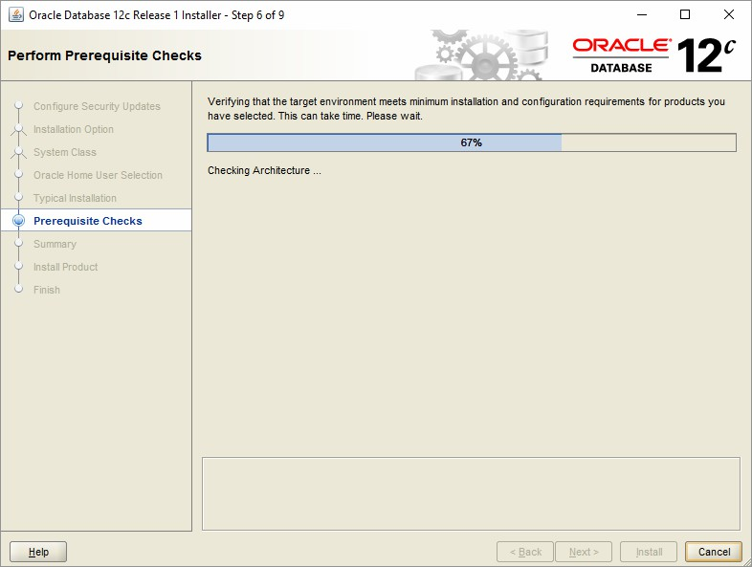
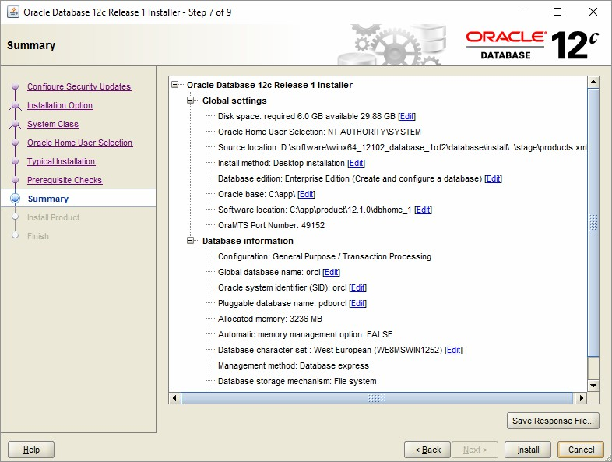

Step 5. in this step you can (1) choose the folder on which Oracle database will be installed, (2) Global database name and password, (3) pluggable database name.

Immplement:

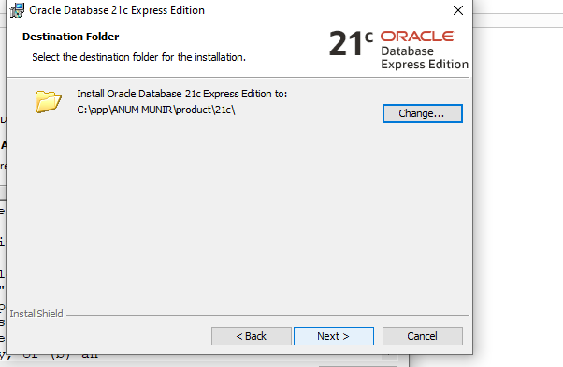

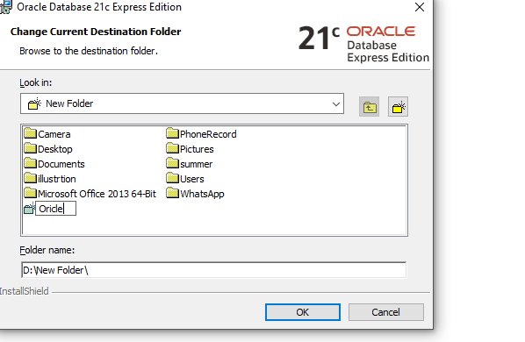

Step 6. The installer performs the prerequisite check.

Immplement:

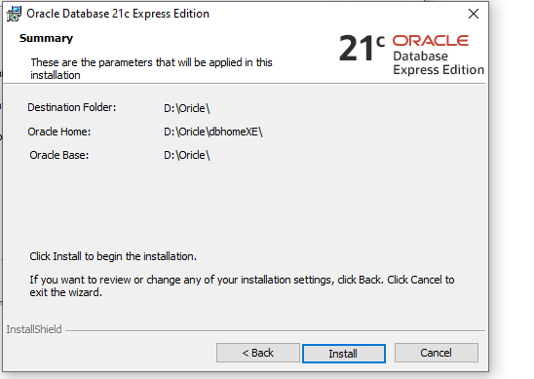
Step 7. The installer shows you the summary of the information such as global settings, database information, etc. You need to review the information and click the install button if everything is fine.

Immplement:

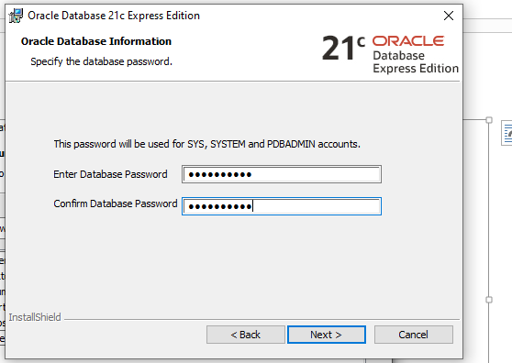

Step 8. The installer starts installing Oracle database. It will take a few minutes to complete, depending on your computer.

Immplement:

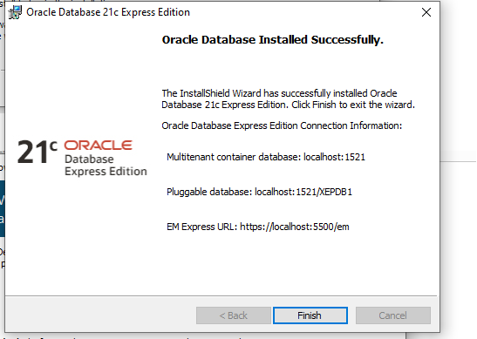
You will see the Database Configuration Assistant window. Click the Password management… button to enter the password for Oracle database accounts.

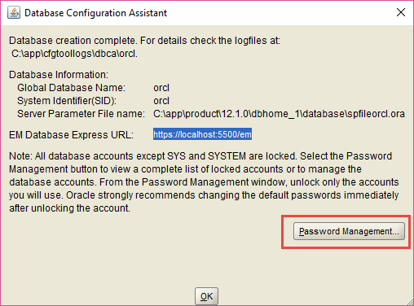
Enter the password for SYS and SYSTEM accounts and then click OK button.

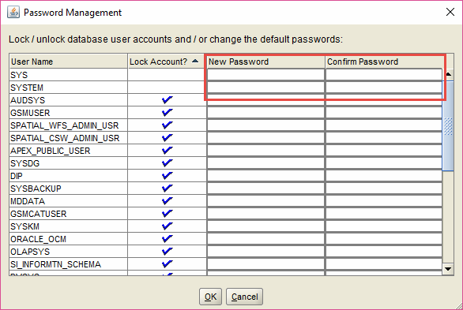

Step 9. Once installation completes successfully, the installer will inform you as shown in the following screenshot. Click the Close button to close the window.

Immplement:

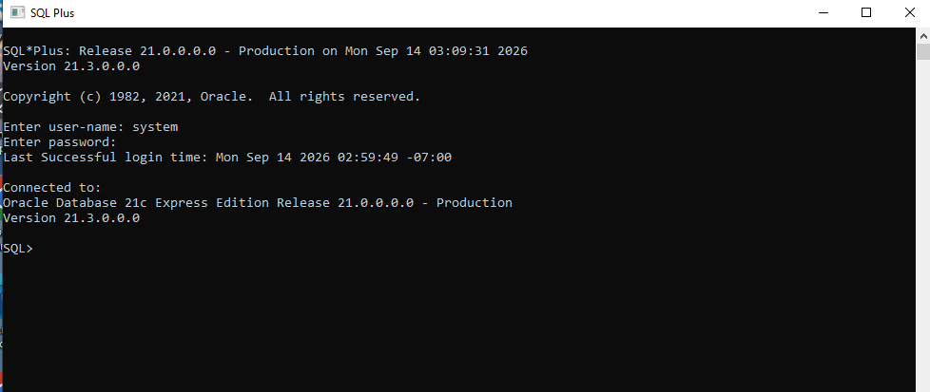
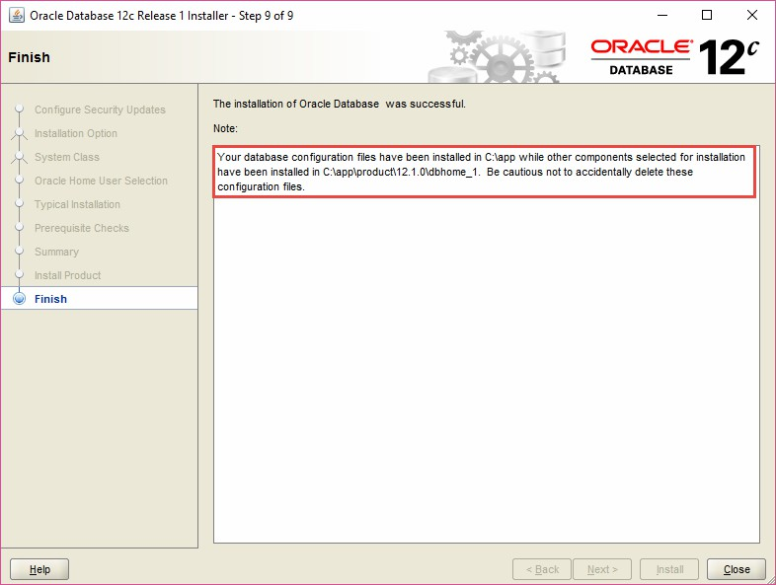

Connecting to Oracle Database

First, launch the SQL developer application provided by the Oracle Database.

Second, right-click the connections node and choose New Connection … menu item to create a new connection.

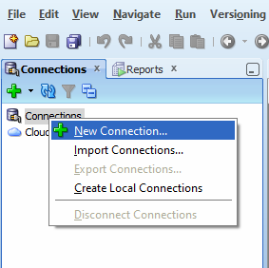

Third, enter the information that you provided during the installation process as shown in the following screenshot. Click the Connect button to connect to the Oracle Database.

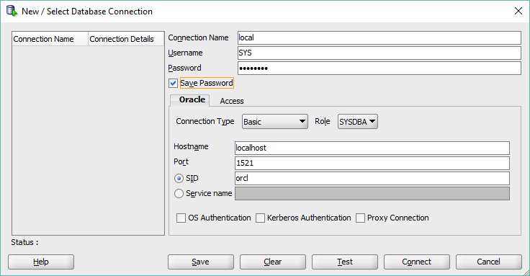

SQL developer will display all objects as shown below.

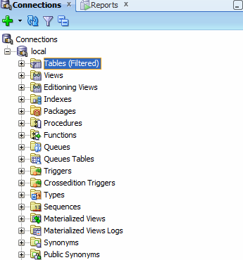

Congratulation! you have installed Oracle Database 12c successfully. Let’s start exploring Oracle.

Adding an entry to the tnsnames.ora file

The tnsnames.ora file is typically located in the following directory:

C:\app\<user>\product\12.1.0\dbhome_1\network\admin\
Code language: SQL (Structured Query Language) (sql)

If you follow the above installation steps, then the file is located at the following directory:

C:\app\product\12.1.0\dbhome_1\network\admin\
Code language: SQL (Structured Query Language) (sql)

You first open the tnsnames.ora file using any text editor such as Notepad or Notepad++. Then, you need to add the following lines at the end of the file:

PDBORCL =
(DESCRIPTION =
(ADDRESS = (PROTOCOL = TCP)(HOST = localhost)(PORT = 1521))
(CONNECT_DATA =
(SERVER = DEDICATED)
(SERVICE_NAME = pdborcl)

)
)
Code language: SQL (Structured Query Language) (sql)

After that, you can save the file and close it. It is time to download and load a sample database into the Oracle Database server.

